Biomedical Engineering Research Based on Computer Propagation Technology: Treatment of neurodigestive diseases
Linyan Li ¹, Hao Chen ², Enquan Shi ³, Han Wang ⁴, Jingyue Wang ⁵,
Yixian Lin ⁶, Tao Yu ⁷, Yaxi Huang ⁷, Han Dan ⁸, Chenchen Wang ⁹,
Qin Yi ^{10, *}
¹ Management, Faculty of Economics, Belarusian state university. Belarus
² School of Electrical and Electronic Engineering, Huazhong University of Science and Technology, Corresponding author, China
³ Education management School of Teaching and Educational Theory and Methods Belarusian State Pedagogical University, China
⁴ Yucheng County People's Hospital, Pharmacy department ,Intersection of Cangjie Avenue and Mulan Avenue, Yucheng County, Henan Province, China
⁵ Faculty of General Education and Foreign Language Auhui Institute of Information Technology China
⁶ Digital Business Management, School of Business, Belarusian state university , Belarus
⁷ Master of Communication Studies, Dhurakij Pundit University, Thailand
⁸ Department of Medical Device Business, Major in Medical Device Business of DONGGUK UNIVERSITY, South Korea
⁹ Global media and communication, Faculty of Arts university of Melbourne, Australia
¹⁰ Sarkov and Markov Memorial Health Informatics Laboratory, Institute of Oncology, Chifeng cancer Hospital, Chifeng University, China
* Corresponding Author Email: qinyimeidicine001@163.com
Abstract. With the support of the Institute of Cancer Hospital of Chifeng University, Sarkov and Markov Memorial Health Informatics Laboratory designed a new working concept of innovative Nursing by using neural network and Brain–computer interface technology. The research team proposed a direct connection between human or animal brain (or brain cell culture) and external equipment. In the case of one-way Brain–computer interface, the computer may accept commands from the brain. Using this point to detect the emotion of patients after surgery and carry out necessary gourds, a two-way information exchange method and model of two-way Brain–computer interface are also proposed. The potential non-invasive Brain–computer interface designed by us has been deeply studied, mainly because of its good time resolution, ease of use, portability and relatively low price. Especially in the specific application and working practice of EEG (Electroencephalography), our achievements directly meet the application of clinical institutions.
Keywords: Obstetrics and Gynecology; Gastroenterology; Artificial Intelligence; Neural Networks; Internet of Things; Virtual Reality Technology.

Introduction
The Brain–computer interface technology is a technology that connects the human brain with external devices such as computers. Due to its high technical content, it was initially used in extremely specialized fields. However, with the maturity of technology, Brain–computer interface technology has become a promising field in the future medical field. Brain–computer interface technology connects the human brain with external devices, which will make many treatment processes in the future medical field more convenient. For example, Brain–computer interface can enable doctors to diagnose diseases more accurately. Currently, doctors diagnose patients through existing medical equipment and manual means. If we use Brain–computer interface technology, we can detect the activity inside the human brain and link it with accurate computer programs. This connection method corrects the physiological reactions of the human body and can provide more accurate reports. The intelligent nursing system has realized the automation, intelligence and informatization of nursing services by introducing artificial intelligence, big data analysis and other technologies. It can provide personalized and accurate nursing plans for patients based on their condition, physiological indicators, and other data; It can monitor and record the nursing process in a timely manner, detect abnormal situations, and improve the safety and reliability of nursing services; Through technologies such as voice recognition and robotics, we can provide patients with more humane and warm nursing services. The research team used Electroencephalography technology to propose a system architecture that can be used for auxiliary nursing in patients with Irritability disorder after surgery, and demonstrated it. The demand of this model was verified through the data of clinical institutions. The research team reports and analyzes the overall model design and experimental data cost analysis [1-5].
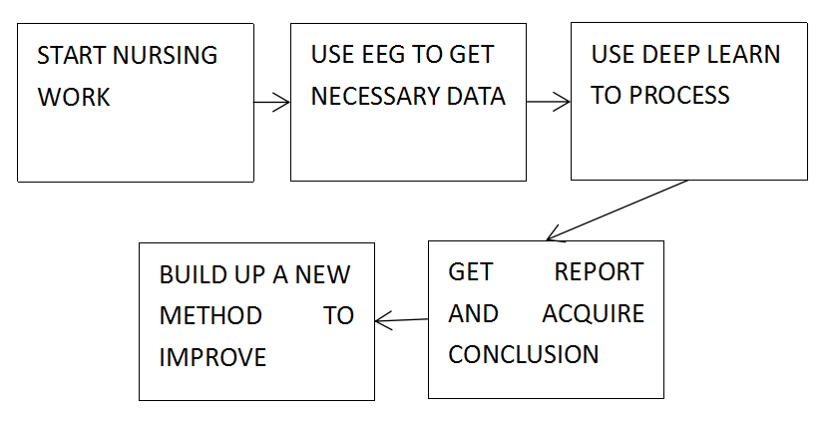
Figure 1. Overall workflow and expression of nursing and clinical work
As shown in Figure 1, we demonstrate the workflow of the model.
The workflow of new media operation includes planning, execution, monitoring, and optimization. Planning is the first step, which involves determining goals, positioning, audience, and content. Execution is the second step and requires the development of a specific operational plan. Monitoring is the third step and requires monitoring and analysis of the effectiveness of new media operations. Optimization is the fourth step, which needs to be adjusted and optimized based on the monitoring results. Only by doing every aspect well can the ultimate goal of new media operation be achieved. In medical treatment, one should adapt to circumstances and work flexibly.

Mechanism of math

Biological neural network
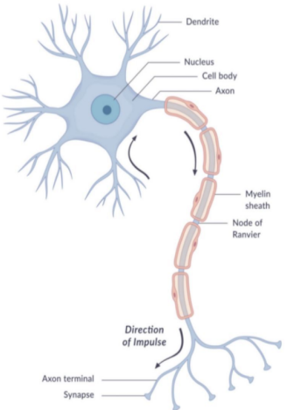
Figure 2. Biological neural networks form a smooth working mechanism in biomimetic engineering through mathematical methods
As shown in Figures 2 and 3. Biological Neural Networks: Generally, refers tArtificial Neural Networks (ANN) systems emerged after the 1940s. It is connected by many adjustable connection weights of neurons, and has the characteristics of Massively parallel processing, distributed information storage, good self-organization and self-learning ability. BP (Back Propagation) algorithm, also known as error Backpropagation, is a supervised learning algorithm in artificial neural networks. BP neural network algorithm can approach any function theoretically, and its basic structure is composed of nonlinear change units, which has strong nonlinear mapping ability.

Principles of Computational Neuroscience
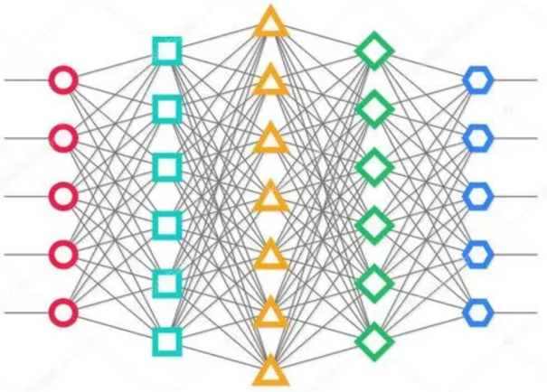
Figure 3. Specific mathematical methods and computer working mechanisms
Moreover, the number of intermediate layers, the number of processing units in each layer, and the learning coefficient of the network can be set according to specific circumstances, which has great flexibility and has broad application prospects in many fields such as optimization, signal processing and pattern recognition, intelligent control, and fault diagnosis. In computing networks, the Activation function of a node defines the output of the node under a given input or set of inputs. The standard computer chip circuit can be regarded as the digital network Activation function that can get "on" (1) or "off" (0) output according to the input. This is similar to the behavior of linear perceptron in neural networks. A function (such as ReLU or Sigmoid function), which is used to calculate the weighted sum of all inputs of the upper layer, then generate an output value (usually nonlinear value) and pass it to the next layer.

Computer and Mathematical Principles
The S-shaped function, as shown in its derivative diagram, has a maximum derivative value of only 0.25. When x is outside the range of [-5,5], its derivative value is almost zero. This situation can cause neurons to be in a saturated state during the training process, and their weights are difficult to update during the backpropagation process, making it difficult for the model to train. This phenomenon is called the vanishing gradient problem.

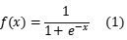 (1)

When the input of the Tanh function is large or small, the output is almost smooth and the gradient is small, which is not conducive to weight update. The Tanh function also requires exponential operation, so it also has the problem of high computational complexity and large computational load. Its functions are represented as follows.

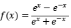 (2)
If the ReLU function is less than 0, its gradient is zero, causing some neurons to be permanently suppressed, ultimately resulting in insufficient feature learning; This is a typical Dead ReLU problem, so it is necessary to improve random initialization to avoid sending too many negative features to ReLU. The mathematical expression for the ReLU function is as follows

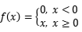 (3)

Leaky ReLU had all the benefits of ReLU at that time, and ReLU passed away without a problem. But in fact, Leaky ReLU is always better than ReLU. Leaky ReLU mathematics operates in this way.

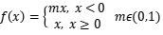 (4)

The PReLU improvement feature has a smaller connection at the negative level, which may be a concern for a dead ReLU issue. Compared to ELU, PReLU is a linear operation with negative levels. Even if it is small, zero will not approach. This is his function.

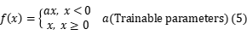 (5)

The defects in ELU functionality are also an improved version provided by ELU to address the Dead Relu issue. Its calculations are slightly more complex than Leaky Relu, but its accuracy does not seem to have significantly improved. Although it is theoretically better than RELU, there is not enough evidence in practice to suggest that ELU is always better than RELU. Its functions are as follows.

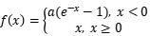 (6)

In neural networks, the Activation function determines the output of the nodes in the input set, and the nonlinear Activation function allows the network to replicate complex nonlinear behavior.
Therefore, in the artificial neural network, Activation function plays a very important role. Its main function is to add nonlinear operations to all hidden and output layers, making the output of the neural network more complex and expressive. The research team believes that after obtaining the required data set from the prediction model, as shown in the figure, it is useful to train neural networks through various Activation function and form control groups through different neural networks, which is more scientific for the overall experiment.
The same group of databases is trained through different Activation function, and the accuracy of its neural network will also fluctuate, so it is very necessary to form a control group with different Activation function.
Artificial neural networks also have preliminary adaptive and self-organizing capabilities. Change synaptic weight values during learning or training to adapt to the requirements of the surrounding environment. The same network can have different functions due to different learning methods and content. Artificial neural networks are systems with learning abilities that can develop knowledge beyond the designer's existing level of knowledge. Usually, its learning and training methods can be divided into two types. One is supervised or supervised learning, where a given sample standard is used for classification or imitation; The other is Unsupervised learning or unsupervised learning. At this time, only learning methods or certain rules are specified, and the specific learning content varies with the environment of the system (that is, the input signal situation). The system can automatically discover the characteristics and regularity of the environment, which is more similar to the function of human brain.

Analysis of Computer Network Modeling Strategies
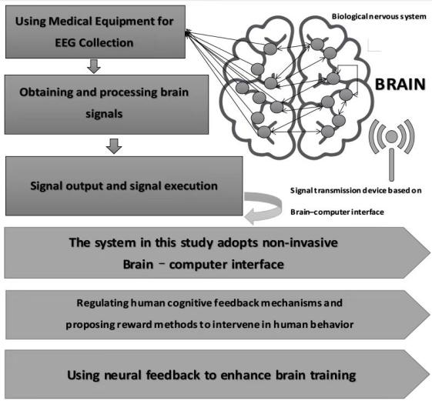
Figure 4. The working mechanism diagram of computer-assisted obstetricians and gynecology performing surgeries
The brain activity patterns recorded by Electroencephalography can not only explain the limited or diffuse pathological manifestations caused by brain diseases, such as epilepsy, tumor, trauma and degenerative diseases, but also have diagnostic value for changes in the central nervous system caused by extracerebral diseases, such as metabolic and endocrine disorders and poisoning. Electroencephalography examination is an effective method to check the changes of brain function. Because the changes of brain function are dynamic and changeable, the existence of brain diseases cannot be completely ruled out for some patients with clinical brain dysfunction who are not found abnormal by Electroencephalography examination. Instead, Electroencephalography reexamination should be carried out regularly to accurately find the disease. We can integrate the concept of music therapy into the overall treatment. During music therapy, we can use Electroencephalography to collect signals and conduct in-depth learning to find rules.
As shown in Figure 3, the overall working mechanism is as follows., A: Set network status to training mode, B: Varying inputs and labels in training data, C: Using the network to calculate forward, including calculating output and loss value, D: Backpropagation adjustment parameters, including gradient zeroing, error backpropagation, gradient descent update, E: Set the network status to test mode, continue with steps 2-4, F: Output report. The following working principles should also be followed during the design of neural networks.
1. Network layer layout: Few neural networks are as simple as a neuron. For example, most neural networks have at least a few layers. If you want to separate data in a nonlinear manner, you will need a hidden layer, which is an artificial neuron layer between the input and output neuron layers.
2. Activation function: in the neural network, the Activation function is a function that determines the output of the artificial neuron when a specific input is given. In my previous tutorial, we used the sigmoid function, which has the advantage of forcing the output to be within a specific range. Another advantage is that the sigmoid function is monotonic - in other words, the order of input values is the same as the order of output values. One drawback of sigmoid functions is that learning may be slow, especially when the sigmoid curve is relatively flat.
Another popular type of Activation function is called rectifier linear unit (ReLU). If x is less than 0, the value of this function is only 0. Otherwise, it is x. ReLU can achieve faster learning processes, even if they produce any difference between negative and positive values of x. From the advantages and disadvantages, hyperbolic tangent or tanh Activation function is often the ideal medium between sigmoid and ReLU.
3. Loss function: The loss is only the prediction error of the neural network, which is determined in each transfer. Ideally, it should be minimized. The Loss function, or the function of loss to output and predicted value, is used to update the weight of the neural network for the next transfer. The calculation of the new weight is based in some way on the gradient, which is a function representing the slope of the Loss function at each point. Different types of Loss function should be used for different types of regression or classification tasks, which are described in more detail here.
4. Optimization Rule: An optimization program is an algorithm or other method that updates the properties of a neural network to minimize losses. For example, it can explain the history of gradient updates, rather than just updating gradients from a set or batch of data samples. It may contain momentum - in other words, the latest update will be a weighted average of all previous updates, and the old weights will decay Exponential decay.
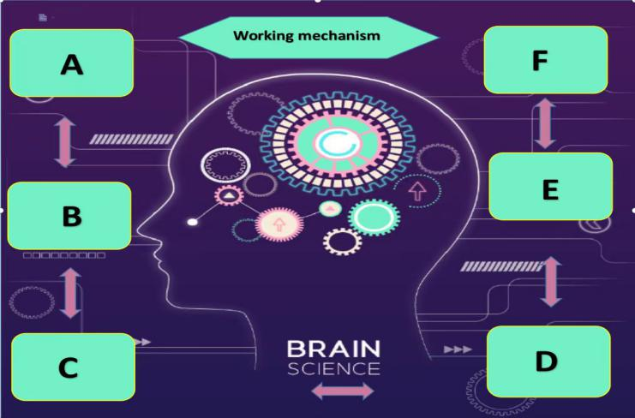
Figure 5. Internet of Things device diagram for disinfection, care, and daily services assisted by nerve stimulatio

Experimental design and data analysis
Experimental design: 10 patients were selected from Xiangtan Medical Center and divided into group A and group B. During the nursing period, group A added music therapy while group B did not. Score based on the patient's emotional rating table (see the recommendation table of the Chinese Medical Association).
Data: The score of adding music in Group A was significantly lower than that in Group B.
Analysis: Adding music intervention throughout the surgical process can have beneficial effects. In the study of music therapy for patients who received breast cancer surgery after specific operations, they were required to select music that could calm and relax themselves in advance, and play music that was selected or recorded by music therapists before and during the operation, which greatly reduced the association of negative memory, reduced preoperative anxiety, made patients feel the strength of support, and also promoted the efficient completion of medical procedures.
New media that integrates artificial intelligence should comply with the following principles
- Responsible for the daily operation and promotion of mobile Internet Personal media platform (mainly WeChat, Weibo and mobile terminals); 2. Be responsible for independently operating WeChat official account, and planning and providing high-quality and highly disseminated content for fans; 3. Responsible for planning and executing daily activities and tracking maintenance of WeChat marketing lines, and sending various WeChat content according to the project; 4. Responsible for increasing the number of fans, increasing attention and fan activity, and timely interacting with fans; 5. Explore and analyze netizens' usage habits, emotions, and experiential feelings, timely grasp news hotspots, and effectively complete thematic planning activities; 6. Follow the development trend of WeChat, pay wide attention to benchmark official account, and actively explore WeChat operation mode; 7. Fully understand user needs, collect user feedback, analyze user behavior and needs The Book of Changes is the theoretical source of Natural philosophy and humanistic practice in Chinese traditional ideology and culture, the crystallization of ancient Han nationality's thoughts and wisdom, and is known as the "source of the road". The content is extremely rich and has had an extremely profound impact on various fields such as politics, economy, culture, etc. in China for thousands of years. According to the discovery of artemisinin by Tu Youyou, the development of the study of Zhouyi may also promote medicine.
In the medical field: 1. Plan and develop departmental operational strategies for new media such as WeChat and Weibo according to project needs, and plan and execute promotional activities; 2. Develop target tasks, complete KPI assessments through activities, communities, article content, and other means, and build effective operational means to enhance user engagement; 3. Having a certain level of data analysis ability, extracting data reports, analyzing promotion effects, and optimizing; 4. Participate in the marketing planning and promotion of the company's overall brand and products; 5. Responsible for external PR work, expanding and maintaining external media resource relationship networks, establishing long-term friendly relationships with KOL, and establishing media archives. The Book of Changes consists of the "classics" of this article and the "biography" of the commentary. The "Jing" consists of 64 hexagrams with symbolic symbols (i.e. hexagrams), each of which includes hexagrams, names, words, questions, and words. The basic unit of hexagram painting is "Yao", which is divided into odd and even paintings. The odd painting is formed by a long horizontal line called "-", commonly known as "Yang Yao"; The occasional painting is formed by two broken horizontal lines, commonly known as the "Yin Yao". Starting from the lowest level, each hexagram has a total of six hexagrams. The six hexagrams are paired with different odd paintings, forming eight to sixty-four different combinations. According to the concept of the three talents of heaven, earth, and human beings, the first and second lines represent the earth, the odd lines represent hardness and softness, the third and fourth lines represent people, the odd lines represent righteousness and benevolence, the fifth and upper lines represent heaven, and the odd lines represent yang and softness. So, using the terms "yang yao" and "yin yao" to refer to odd and occasional paintings is a manifestation of the pan yin yang theory.
In Zhouyi, the hexagram is based on the natural image, which refers to the appearance and form of things in nature. The image presented by the sun, moon, and stars is called the celestial image, while the image presented by mountains, rivers, plants, and trees is called the earth image. The images in the Book of Changes summarize and organize the phenomena in nature, and are expressed through hexagrams. The title "Xiang" in "Yi Zhuan" refers to "Xiang Zhuan". From the perspective of the upper and lower scriptures, it can be divided into two parts: "Xiang" and "Xiang". From the perspective of interpreting the hexagrams, it can also be divided into two parts: the elephant and the small elephant. Elephants are symbols of divination, while small elephants are symbols of divination. We believe that this may have a philosophical overlap with the internal regulation of the human body. Therefore, it is also a very interesting little discovery.

Conclusion
Our experiment has some enlightening significance. Although it has not yet been promoted, the validation of the effectiveness of music therapy confirms the necessity of implementing algorithms such as neural networks as a whole. Therefore, our preliminary achievements are worth further exploration by researchers worldwide who are interested.

Acknowledgments
In this research paper, the Natural Science Foundation of Chifeng City in 2023: support for clinical prediction model research based on artificial intelligence and Computational neuroscience, and also won the support for the intelligent medical engineering research project in the era of in-depth cooperation between China and Russia in 2023 from the Ministry of Education of China.

References
- Hakvoort Laurien & Tönjes Djemida. (2023). Music-mechanisms at the core of music therapy: Towards a format for a description of music therapy micro-interventions. Nordic Journal of Music Therapy (1). doi:10.1080/08098131. 2022. 2070925.
- Li Jing ze & Ji Hui bin. (2022). Philosophical Reflections on Music Therapy Research in China. Clinical Medicine Research (6). doi: 10. 11648/J. CMR. 20221106. 16.
- Ahessy Bill. (2023). ‘Boom Boom in the Zoom Zoom Room’: Online music therapy with children and adolescents with visual impairment. The British Journal of Visual Impairment (1). doi: 10. 1177/02646196211029342.
- Hansen Tang. (2022). Evidence from a Systematic Review and Systematic Review Meta-Analysis on the Effectiveness of Music Therapy for Dementia Patients is Summarized. MEDS Clinical Medicine (5). doi: 10.23977/MEDSC. 2022. 030516.
- Ruotsalainen Jaana, Carlson Emily & Erkkilä Jaakko. (2022). Rhythmic exercises as tools for rehabilitation following cerebellar stroke: A case study integrating music therapy and physiotherapy techniques. Nordic Journal of Music Therapy (5). doi: 10.1080/08098131. 2022. 2026452.

